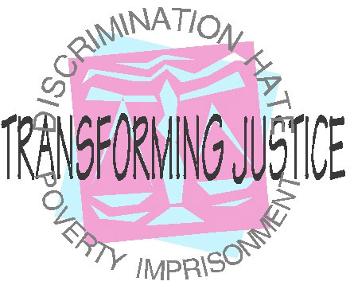
Introducing the Transforming Justice Coalition
In April 2006, the Sylvia Rivera Law Project in New York City contacted LGBT, prisoner rights, and human rights activists and attorneys across the country to create a national conversation about transgender imprisonment issues. Over the next year and a half, a vibrant coalition of local and national organizations came together to plan Transforming Justice, the first-ever national gathering of LGBTIQQ former prisoners, activists, attorneys, and community members to develop national priorities towards ending the criminalization and imprisonment of transgender communities.
http://www.transformingjustice.org/
Out of this gathering of activists emerged plans for an event that could:
- build a shared conversation and analysis among the LGBT, anti-prison, and prisoner rights movements about the root causes of imprisonment, poverty, and criminalization in transgender communities;
This is a summary of the vision set by the Transforming Justice Coalition. TAP supports this vision by attempting to provide a safe space for transgender ex-prisoners transitioning back into society. This information is provided to spread this growing vision and not as an endorsement of TAP by Transforming Justice.
- prioritize and build the leadership of transgender and gender non-conforming people most impacted by prisons, poverty, and policing; and
- create space to share and develop strategies to end the cycles of imprisonment, criminalization, poverty in our communities.
All of this led up to the weekend of October 13-14, 2007, when over 250 people gathered at the City College of San Francisco for two days of learning, connecting, and visioning.
Building Unity
Near the close of this event, the following five points of unity were explored:
- We recognize cycles of poverty, criminalization and imprisonment as urgent human rights issues for transgender and gender non-conforming people.
- We agree to promote, centralize, and support the leadership of transgender and gender non-conforming people most impacted by prisons, policing, and poverty in this work.
- We plan to organize to build on and expand a national movement to liberate our communities and specifically transgender and gender non-conforming people from poverty, homelessness, drug addiction, racism, ageism, transphobia, classism, sexism, ableism, immigration discrimination, violence and the brutality of the prison industrial complex.
- We commit to ending the abuse and discrimination against transgender and gender non-conforming people in all aspects of society, with the long-term goal of ending the prison industrial complex.
- We agree to continue discussing with each other what it means to work towards ending the prison industrial complex while addressing immediate human rights crises.
Conference attendees agreed to continue discussions in our home communities on these points of unity, particularly focusing on point #4 as an exciting and fertile place to begin building solutions to the prison-poverty crisis.
Additionally, participants voted on concrete next steps to guide our work moving forward. All of the next steps include centralizing and building the leadership of transgender people most impacted by poverty, policing, and prisons, specifically people who have been imprisoned, arrested, or detained:
- Develop a national platform on transgender immigrant rights issues & ask others to sign on to it;
- Foster local conversations about responding to anti-LGBTQQ and interpersonal violence without relying on the prison industrial complex;
- Create and strengthen local resources for transgender and gender non-conforming people coming out of prison and jail;
- Create a national coalition that can support local transgender organizing to end the cycles of poverty, criminalization, and imprisonment.
Moving Forward
Continue to check the website (www.trans formingjustice.org) for progress updates, resources, and ways to get involved. For more info please contact the TGI Justice Project, (342 9th St., #202B, San Francisco, CA 94103, 415-252-1444, or infoATtranformingjustice.org).

The TransAction Program emerged as a vision from Jen Durr Press, publisher of TRANS SPIRITUALITY, a quarterly zine by and for incarcerated transpersons and their allies. The zine provides a sense of community for trans persons and gender variant prisoners whose diverse spirituality helps them endure the harsh experience of the prison industrial complex.
Upon release from prison, many transgender prisoners have no family to turn for support. They face a life of homelessness, often returning to the street environment from which they came. This inevitably leads to recitivism, if not premature death. While the Transforming Justice Coalition builds a network of concerned citizens around the country to address these needs, Jen Durr Press is attempting to begin a prototype program for transgender ex-prisoners, located here in the Detroit area.
The vision for the “TAP” program is to solicit local support to help sustain its mission to help trans ex-prisoners rebuild their lives and remain free from legal trouble. The TAP program is currently seeking potential “advisors” to help organize its vision and mission into a sustainable organization. If you would like more information or want to express your interest in becoming involved in this pioneering program, please contact the current program director Steph Turner at steph@transinjustice.org. (Steph Turner is also a board member of TGMI, but this is not to be taken as an endorsement by TGMI.)
TAP
The TransAction Program is a pioneering attempt to provide support to transgender ex-prisoners trying to rebuild their lives. Because everyone matters.
TransAction Program


TransAction Program
417 Sixth Street, #8
Rochester MI 48307
(248) 841-1023

